**ENGINEERING JOURNAL TEMPLATE**

# Date

25th Nov- 29Nov

# Solutions

* After many attempts this week I finally got code publishing the topic speed messages to the mqtt broker
* MQTT does not save the data so I using SQlite as a local database to store the current speed data. As it is local it does not require a server. In android studio I am using SQL commands to create the database and it can be viewed on DB Browser
* 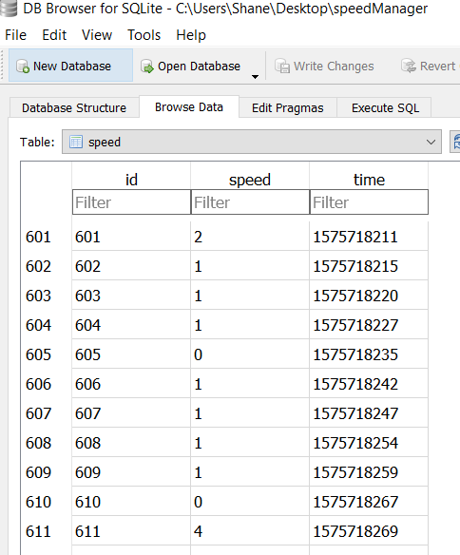
* MAP Activity would not display location with created API key, documentation on Google Maps Platform and Youtube helped me a lot. <https://developers.google.com/maps/documentation/android-sdk/config>
* 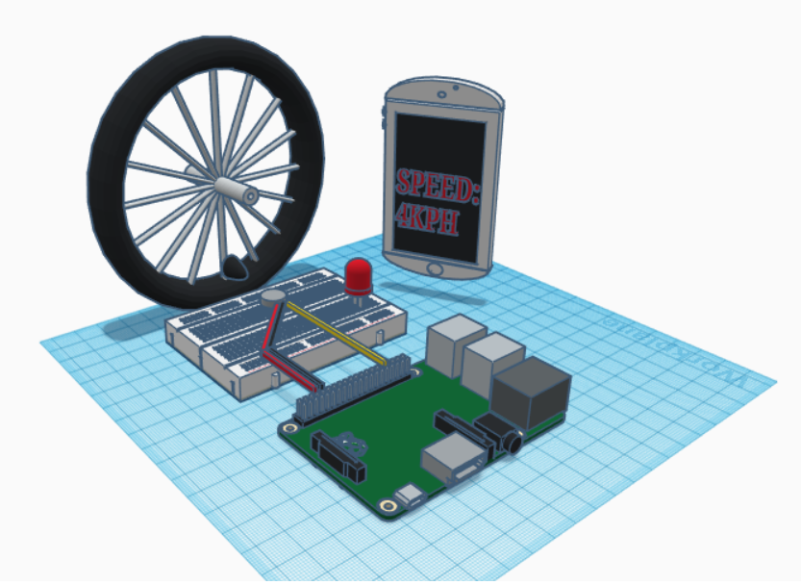
* CAD design of how I envisage to demonstrate my project. A magnet connected to the whell of a bike. As the wheel spins, the magnet will turn the hall effect sensor off. The time it takes for the magnet to do this every rotation is what we need to know in order to calculate speed

# Reflection

Very happy to get mqtt communication working. Great examples of SQLite on internet which helped to create database quickly…<https://www.youtube.com/watch?v=p8TaTgr4uKM>

# Issues:

*Software:*

* + Distance not showing correct reading I don’t think. I will try to fix it before demonstration, but it is not a massive issue.

# Tasks

Prepare for demonstration

Tidy up placement of the buttons on front end of the app

Update github and the architecture diagram

First page of App and Flow Chart below

